

Project Completion Documentation

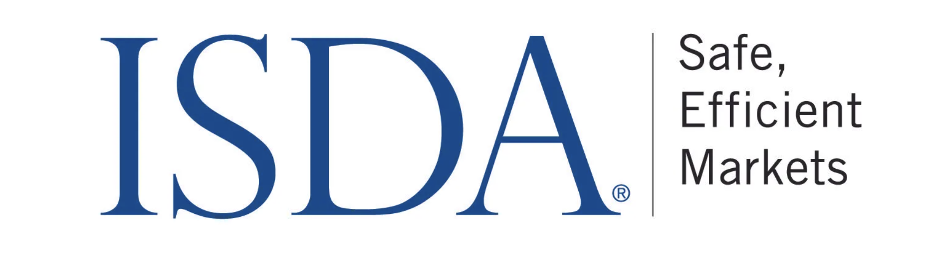


Author:
Sai Harshith Reddy Muthani

1. Executive Summary 3
2. Project Overview 3
2.1 Project Manager 3
2.2 ASU Build Team 3
2.3 Project Timeline 3
2.4 Project Timeline and Sprints 4

3. Project Performance 5
3.1 Problem Statement 5
3.2 Project Scope 5
3.3 Deliverables 5

4. Development 6
4.1 Architecture 6
4.2 Agent Setup and Scaling 7
4.3 AWS Cloud Services 9
4.4 Key Milestones 9

5. Research Work 10
5.1 Model Comparison and Analysis 10
5.2 Prompt Development for Clauses 11

6. Challenges 12
7. Future Scope 13
8. Appendix 13

1. Executive Summary

The project aims to develop an agent architecture leveraging prompt engineering techniques to extract clauses and identify variants from a provided Master Agreement. The extracted information will be presented in a JSON format that combines the Common Domain Model (CDM) JSON structures for the individual clauses.

2. Project Overview

2.1 Project Manager
AWS Leads
Arun Arunachalam - Solution Architect
Tom Orr - Program Manager
Heather Morris - Account Manager

2.2 ASU Build Team
Sai Harshith Reddy Muthani - Full-stack Engineer

2.3 Project Timeline
June 19, 2024 - August 7, 2024

2.4 Project Timeline and Sprints

Item # | Iterations | Deliverables | Date planned
1 | Pre - POC | - Data sources are collected  - Discovery workshop readout | 6/19 - 6/26
2 | Week 1 | - Environment set-up  - Exploratory data analysis (EDA) and document sign-off  - Iteration #1- Exploring different LLM models & techniques. | 6/26 - 7/3
3 | Week 2 - 3 | - Development Iteration #2 delivery  - [Solution Architecture approach] | 7/3 - 7/17
4 | Week 4 - 6 | - Development Iteration #3 delivery  - Final evaluation and product delivery  - Documentation  - Solution hand-off to production-phase team | 7/17 - 8/7

3. Project Performance

3.1 Problem Statement
ISDA’s pioneering work in developing the ISDA Master Agreement and a wide range of related documentation materials, and in ensuring the enforceability of their netting and collateral provisions, has helped to significantly reduce credit and legal risk. The Association has been a leader in promoting sound risk management practices and processes, and engages constructively with policymakers and legislators around the world to advance the understanding and treatment of derivatives as a risk management tool.

ISDA’s work in three key areas – reducing counterparty credit risk, increasing transparency, and improving the industry’s operational infrastructure – show the strong commitment of the Association toward its primary goals; to build robust, stable financial markets and a strong financial regulatory framework.
The challenge is to develop a POC that enables ISDA and ASU AI CIC to collaboratively create a solution for extracting clauses and identifying variants from a provided Master Agreement, and subsequently presenting this information in a JSON format.

3.2 Project Scope

Development of the prompt engineering framework to extract the clauses and identify the variants from the provided Master agreement and present it in the json format which is the combination of the CDM (Common Domain Model) json structures of the individual clauses.

3.3 Deliverables
- A cloud mechanism that accepts a Master Agreement and generates CDM (Common Domain Model) JSON structures for the identified clauses.
- A scalable CDM generation agent equipped with prompts for the specified clauses.

4. Development

4.1 Architecture

This project was developed using AWS. When a user uploads a master agreement ( strictly in pdf format) into a S3 bucket, the trigger-handler lambda which contains a list of all the clauses to be identified is triggered, which in turn invokes a bedrock agent, and a session is created with the agent. The bedrock agent is powered by a LLM (Claude 3 OPUS), all the agent invocations are handled by trigger-handler lambda. The agent consists of action-group lambda which further invokes action group functions based on the clause identified. After CDM is generated for all the clauses, the agent finally combines them into a JSON array. The final CDM JSON array is then saved into a separate S3 bucket.

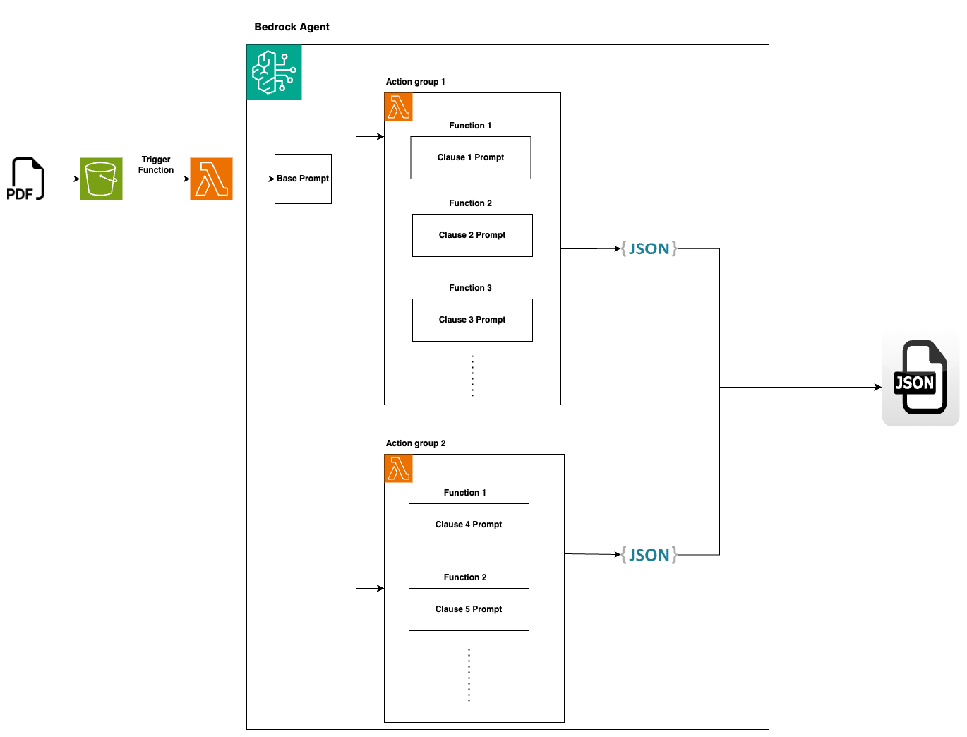

4.2 Agent Setup and Scaling

The application should be deployed in us-west-2 region
Step 1: First, download the folder provided of the application
Step 2: In the folder there are two zip files which represent lambda function and lambda layer. There is also a template.json file present in the folder.
Step 3: Create a s3 bucket and upload all the files in this folder. The S3 bucket name should match with the bucket name in template.json file.
Step 4: Run the command:
aws cloudformation create-stack --stack-name CDM-AgentStack --template-url object_url_of_the_template --capabilities CAPABILITY_NAMED_IAM
Replace object_url_of_the_template with original url.
After completing the above steps, a bedrock agent is created. Two S3 buckets named with prefix “ma-pdf-input-bucket” & “cdm-output-bucket” will be created in the AWS account. And all other resources will be created as well.

The agent can be guided by instructions that help it clearly understand its role.
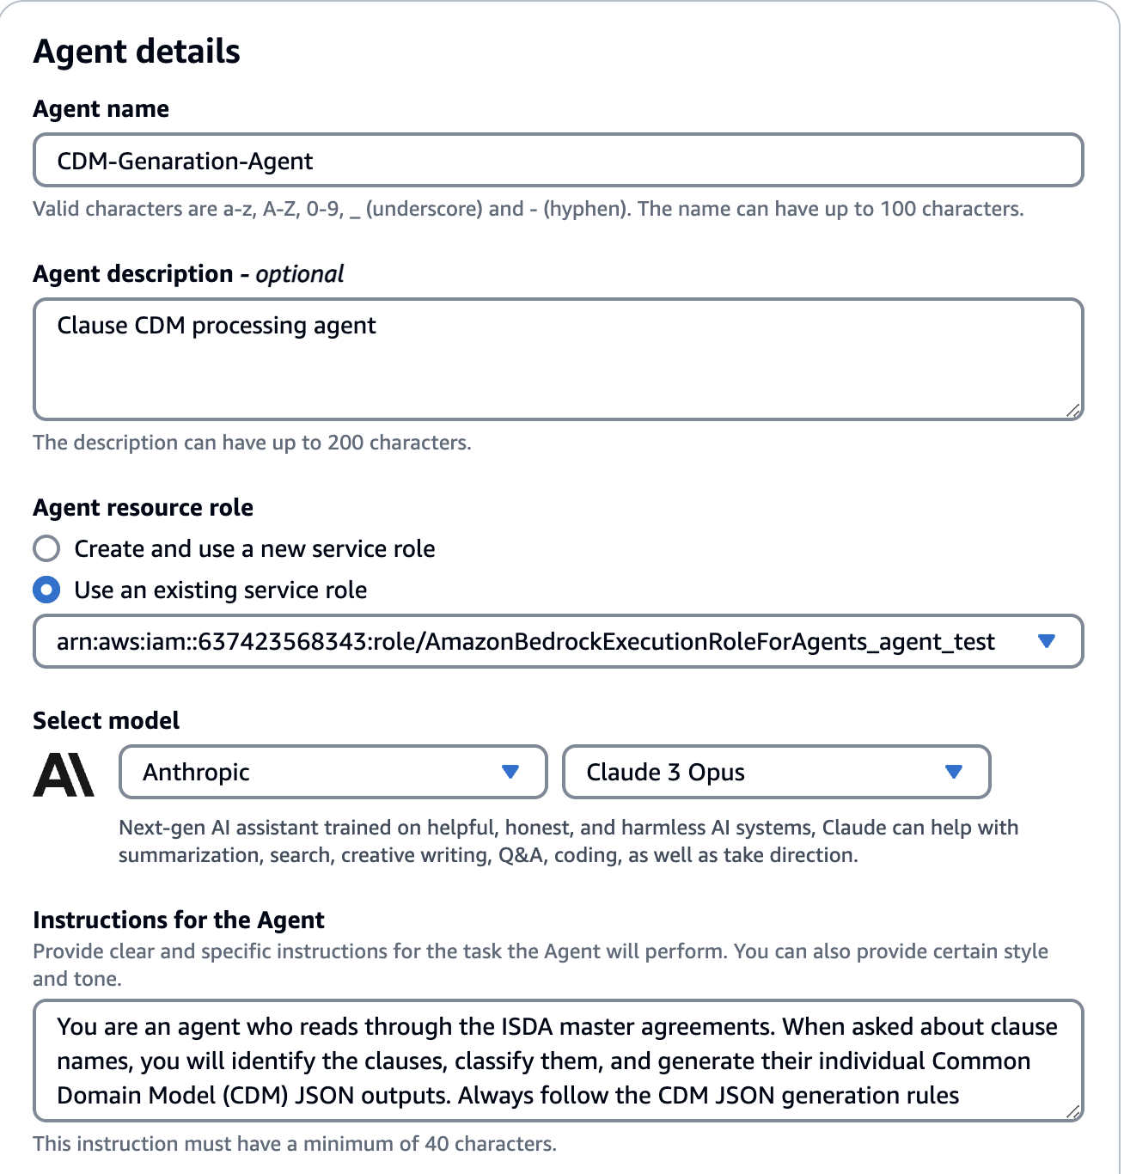
Add action groups as needed; if clauses are similar and belong to the same category, include them in an existing action group. The agent will call the action group and subsequently its functions based on the descriptions. Add these carefully so that the model can distinguish / identify them.
If the agent has to be expanded to include new clauses, the bedrock agent has to be modified. For each clause a new action group function has to be created. Select an action group and click on the add “action group function” .
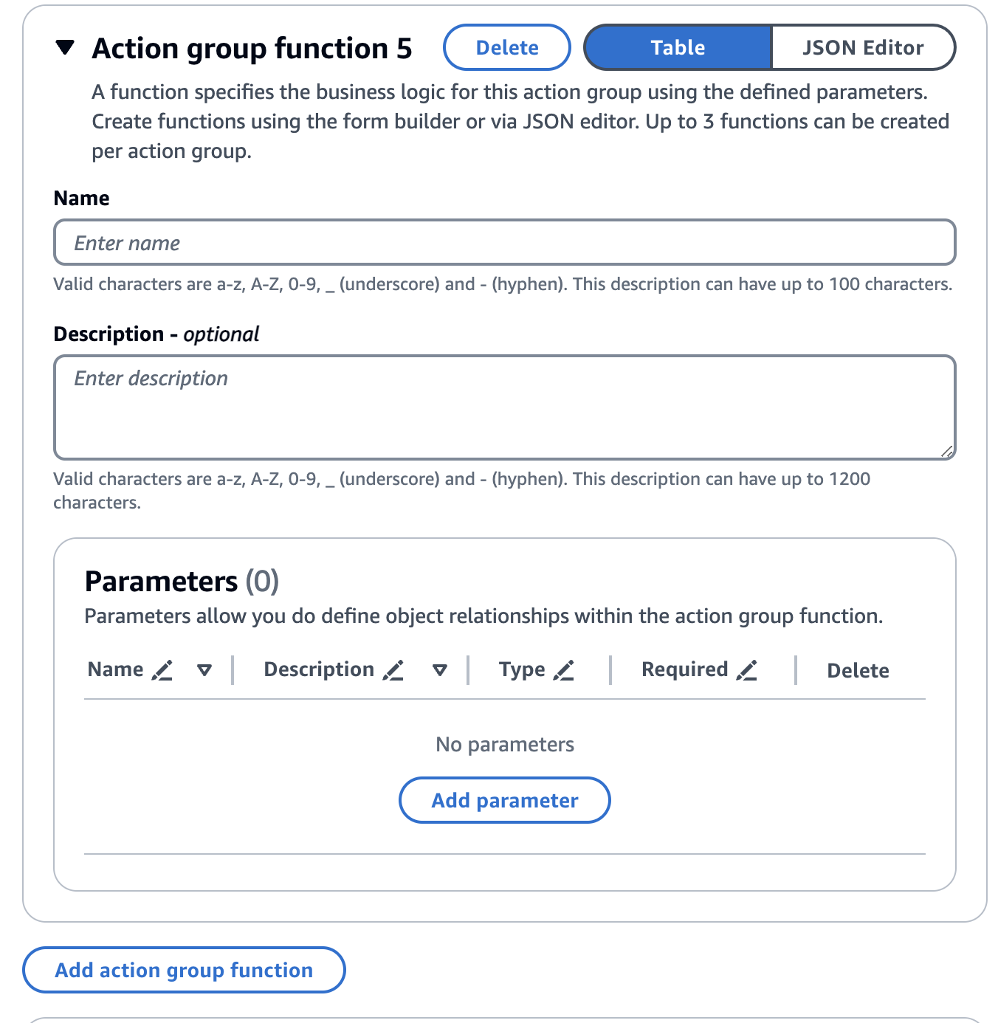
Enter a Name and description for the new function following the style of existing functions. Now add this as a function in the lambda code associated with the action group, similar to existing ones. In this sub-function of lambda replace the prompt string with prompt for this clause. Also add an “if” block as shown below. Deploy changes. Prepare the agent.

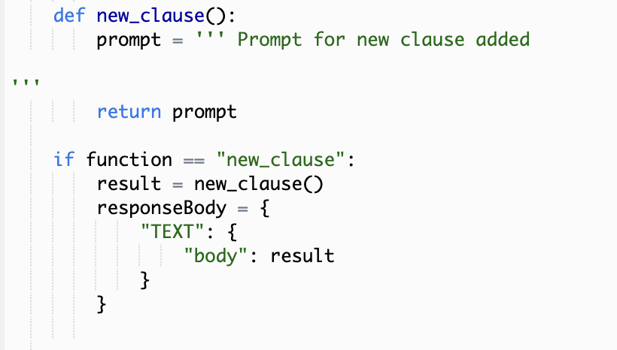
Finally, in the trigger handler lambda function add the clause name to the list which consists of all the clause names.
Now when a master agreement is uploaded, the CDM JSON structure for the new clause is also generated along with all other clauses.

4.3 AWS Cloud Services

- AWS S3 receives user uploads and stores output generated.
- Amazon Bedrock will manage and interact with the LLM to generate CDM JSON outputs.
- AWS Lambda to handle trigger notifications and sessions with Bedrock agents.

4.4 Key Milestones

- Development of prompts for each clause which are used to generate CDM JSON structures.
- Testing various LLMs using developed prompts to assess performance.
- Creation of a CDM generating bedrock agent.
- Integration of file upload capability using S3 buckets.
- Testing and quality assurance.

The mentioned milestones have been completed as expected.

5. Research Work

5.1 Model Comparison and Analysis

Several Large Language Models (LLMs) were tested before determining that Claude 3 OPUS was the best performer for this task.
Starting with models in the Claude 2 series, including Claude 3 Haiku and Claude 3 Sonnet, these models demonstrated limited capabilities in clause identification and Classification. While they could identify clauses, they struggled to capture all relevant details and correctly determine the clause variants based on those details. These models lacked the ability to classify clauses into variants effectively. Except for Claude 3 Sonnet, the others also failed to generate accurate JSON structures containing all necessary information.

Claude 3.5 Sonnet, one of the latest models tested, performed notably better than the previously discussed models. This LLM is approximately 1.5 times faster than Claude 3 OPUS in generating JSON structures. It is equally proficient with Claude 3 OPUS in generating correct json structures. However, Claude 3 OPUS surpasses Claude 3.5 Sonnet in reasoning and classifying clauses into variants.

OPUS is also more flexible in prompt engineering, effectively handling sensitive instructions and performing better in edge cases. In contrast, Claude 3.5 Sonnet is more rigid in its prompt engineering, often bypassing instructions in tricky scenarios, which negatively impacts its ability to produce accurate CDM JSON outputs.

Claude 3.5 Sonnet also struggles when a clause has two variants, one for each party. In such cases, it often mis-classifies one of its parties, if classified correctly, retrieves only partial information, leading to improper formatting. On the other hand, Claude 3 OPUS handles these cases correctly, ensuring accurate classification and complete information retrieval.

Another capable model tested was Meta Llama 3.1, which outperforms Claude 3.5 Sonnet and competes with Claude 3 OPUS in terms of classification logic and reasoning. However, Meta Llama 3.1 is significantly slower, with OPUS being 2 times as fast.

Meta Llama 3.1, in some cases, demonstrates better reasoning than OPUS without requiring special instructions, but it lags behind OPUS in other scenarios. Additionally, Meta Llama 3.1 also faces difficulty in generating complex json structures at times, such as ratings based variants.Overall, Claude 3 OPUS is the most consistent performer and responds effectively to instructions, making it the best choice for this use case.

5.2 Prompt Development for Clauses

In this project, prompts for clauses are structured in a consistent manner, enabling a uniform approach across all clauses and simplifying the integration of new clauses into the agent. All the prompts are added to the action-group lambda function.
The prompt starts with an introductory line stating the clause name/names and then a set of rules follow in a <rules> tag.

Rules start with a paragraph asking the model to thoroughly review the entire document, including all schedules and annexes.

The following statement instructs to follow a step-by-step approach, directing the model to first classify the clause into variants and then generate the corresponding CDM JSON structures based on the identified variant.

Here, provide additional instructions for taking a step-by-step approach if the clause variants differ between the parties. Include any relevant guidance, such as setting default values, as necessary.Any similar instructions such as providing default values/ assumptions can be stated here.

Next, all the variants for the clauses can be listed, definition of each variant should be provided along with their respective JSON formats enclosed in the <json format> tag for better clarity.

If the formats are complex and may confuse the model when forming the correct structure, include an <example> tag that encloses sample portions of these complex structures. For instance, in cases like ratings-based variants in MTA and Threshold clauses, where the structuring of ratings and rating institutions is unclear, providing examples can help prevent improper structuring.

After all the variants and formats are stated, important instructions should be enclosed in tags such as <important notes>, <strictly follow>, instructions within these tags should be helpful for the model in distinguishing between the variants. Any subtle details or aspects which can determine the variant has to be placed in these tags. Also add instructions which help the model in identifying the “other case” or “N/A” as these might not be properly established from the list of variants.

<strictly follow> tags can also be used at the introductory statement for rules if the model bypasses certain important instructions.
Finally, List all the CDM fields and their descriptions.

While providing specialized instructions for the model based on any misinterpretations, enquire the model (in the same session) on what was the base logic for its output. Understand its reasoning in terms of identification, classification etc. and then provide the instructions to help the model understand/interpret better.
NOTE: The key focus of this prompt engineering task is accurately classifying the clause into the correct variants. Once the variant is identified, generating the JSON structure becomes a straightforward task for the model.

Besides all these, providing a set of example statements from the master agreement which determine the clause variant can significantly enhance model performance. Providing detailed explanations for each clause variant along with the definitions can also improve the performance by multiple folds.

Overall the prompt can be structured as follows:
1) Introductory statement containing clause name before the start of <rules> tag.
2) Instructions emphasizing the importance of a thorough document review.
3) special instructions - (optional)
4) List of variants, definitions along with example json structures.
5) Important instructions enclosed in specialized tags.
6) List of CDM fields and descriptions.

6. Challenges

- One significant challenge has been prompt engineering. The prompts need to be designed and structured in a way that allows them to be adaptable for various clauses. The challenge lies in understanding the nuances of each clause and incorporating additional instructions to enhance accuracy, which requires careful attention to detail and a deep understanding of the underlying context.

- Another major challenge was managing the agent’s responses to each clause and orchestrating the resulting JSON structures to produce the final CDM JSON output. This required careful coordination to ensure that each response was accurately retrieved during the agent session and integrated into the overall structure.

7. Future Scope

- Fine Tuning: Curating a set of example statements for each variant of various clauses, along with their formats, can be an effective strategy for fine-tuning a large language model (LLM). This approach can significantly reduce the effort required for prompt engineering and optimize the overall performance of the model.

- The current CDM generation agent can be extended by adding new action group functions or creating entirely new action groups to introduce additional clauses. This expansion would offer greater capability to handle a wider range of clause variations.

8. Appendix

GitHub link - Click here

